Group 11
Baimyrza Nurlybek 23B031239
Khalimov Rustam 23B031473
Kalmahanbet Nurasyl 23B030297
Satbay Alikhan 23B030396
Maksut Bekzat 23B031362
Research Methodology – Part A
A.1 Research Gaps
Research gaps: The current literature primarily addresses the effect of ERP systems in foreign countries (e.g. China, Morocco), and there is extremely little information about Kazakhstan. The study mentions that Kazakhstan's business environment is unique, and we know nothing at all about what it does with ERP systems in Kazakh companies. Specifically, there is no data on customer service improvement following the use of ERP: interior performance indicators (reduction of cost, growth of profit) are considered in the majority of studies but not changes due to speed and response quality towards the customer. Therefore, there is a necessity for empirical studies on the effect of ERP on customer satisfaction and service speed efficiency primarily in the context of Kazakhstani SMEs.

A.2 Statement of the problem
Against the background of globalisation and increasing digitalisation, Kazakhstani companies actively develop ERP systems (for instance, it is predicted that by 2025 34% of large firms and 18% of medium firms in the republic will implement ERP), hoping for improving efficiency. While, on the other side, the customer expects quicker service (76% of global clients expect a 24-hour response). But practicably, ERP projects take up barriers also in the form of high expenses, technical complications, insufficient staff training, and problems in integrating systems. In Kazakhstan, where IT infrastructure and digital preparedness is yet evolving, it remains doubtful that Kazakh companies realize the mentioned customer service improvement following the ERP switch over. The reason is that there remains a distance between the assumed theoretical effect of ERP in boosting speed in response towards customer demands and the ways in which such systems impact operational efficiency and customer satisfaction in the local environment. The empirical identification of which factors both technical and organisational identify the success of ERP projects as pertains customer service is compulsory.

A.3 Research Questions
• Research questions: In evading such gaps, the following questions emerge:
What is the effect of ERP system implementation on customer responsiveness and service satisfaction in Kazakhstani SMEs?
• Technical (such as integrating ERP with CRM and other IT systems, deployment model) and organisational (employee training, data handling) variables that can facilitate customer servicing metrics improvement during ERP implementation?
• What practices and processes do organisations need for improving and sustaining improvement in handling customer demand following an ERP implementation?

A.4 Objectives of Research
• Assess changes in primary customer service indicators (e.g., average response time, percentage of first-contact resolution of requests, customer satisfaction indicators) following ERP implementation.
• Examine the function played by ERP system convergence with CRM and organisational factors (employee training, data quality, process re-engineering) on these measures.
• Draw up practical recommendations for optimising ERP implementation for customer service efficiency improvement on the example of different Kazakhstan's SMBs.

A.5 Scope of the study
The study focuses on small and medium-sized enterprises (SMEs) in Kazakhstan in a few strategic sectors (e.g., manufacturing, retail, services). ERP systems are corporate solutions for enterprise resource managing (e.g., SAP, Oracle, 1C, etc.) and their CRM integrating. The consideration is given to customer service indicators (speed of response, satisfaction) and ERP implementation determinants, whereas the financial results (revenue, profit) evaluation or long-term effects over customer service period are out of this study's scope. Geographically, firms from various country's regions are considered, and both pre- and post-ERP implementation situations are examined.

A.6 Research Hypotheses
H1: The ERP systems' implementation in Kazakhstan's SMEs has a statistically significant effect on decreasing the average response time towards the customer.
H2: The deeper ERP integration with CRM systems is positively associated with better service indicators (better customer satisfaction, larger share of first-time resolutions).
H3: High staff training and the availability of systems for managing data quality strengthen the ERP implementation impact on customer service.
H4: The companies with cloud-based ERP solutions have speed earlier than companies with on-premise solutions due to superior availability of real-time data.

A.7 Conceptual Model or framework
• Independent Variables: ERP implementation parameters — including whether an ERP system is present, the extent of its integration with CRM, the chosen implementation model (e.g., on-premise or cloud-based), the extent of process re-engineering, and the level of investment in training and data management.
• Dependent Variables: Customer service performance indicators — such as average response time, the share of inquiries resolved, customer satisfaction, and customer retention.
• Moderators/Mediators: Industry characteristics, company size, and the level of technological infrastructure may either strengthen or weaken the impact of ERP implementation on service outcomes.
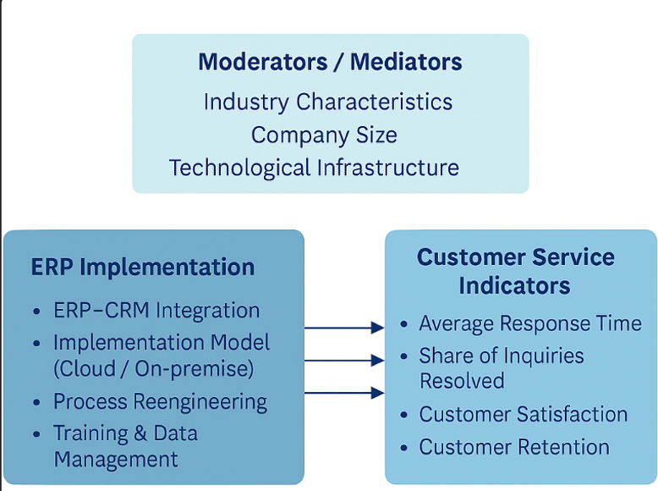

Research Methodology – Part B
B.1 Type of Research
The study is my work in which I combine the strengths of both quantitative and qualitative research. The numbers part of the study helps to track improvements with exact figures. For instance, it assays the speed of how the employees perform the customers' requests, whether customer satisfaction has increased, or sales have improved after the implementation of ERP, CRM, and SCM.
The people's part comes from the interviews where they talk about their experiences, and views, and share their problems. Such a combination is effective because the figures mainly demonstrate the general tendency, while the narratives of the employees tell how the changes happened at the company.
B.2 Data Collection
We will gather our data through surveys and interviews.
The surveys will utilize simple questionnaires consisting of close-ended questions and will be handled to the workers such as IT managers and customer service staff. The answers will show the quantifiable results of the parameters of response speed, efficiency, and customer satisfaction.
The interviews will consist of open-ended discussions with project managers and IT specialists trying to grasp the difficulties faced and the good things noticed.

B.3 Sample & Population
For this study, it includes employees of small and medium-sized enterprises (SMEs) in the service and retail sectors in Kazakhstan who have implemented enterprise resource planning (ERP) systems. These industries are chosen because of the large number of customer interactions, which makes the effectiveness of responding to customer requests a critical performance indicator. A target group will be selected for this study.
Respondents will include customer service representatives, sales managers, and IT specialists who manage or utilize the ERP system on a daily basis as part of their customer service duties.
Given the time constraints and study accessibility, a convenient sampling method will be employed to gather the data. To guarantee the applicability of the information gathered, the survey will mainly target respondents from significant economic hubs..

B.4 Tools/Techniques
The quantitative data collected during the structured survey will be analyzed using software.
Statistical Package for the Social Sciences (SPSS). To achieve the objectives of the study, the analysis will include several statistical methods. At first:
Descriptive statistics, including frequency, averages, and standard deviations, will be used to summarize the demographic characteristics of respondents and key variables related to ERP usage and customer response effectiveness. Afterwards,
A correlation analysis will be conducted to examine the nature and strength of the relationship between specific ERP system functions (e.g., data integration, process automation) and customer response metrics (e.g., response time, resolution rate). Finally,
Regression analysis will be used to test research hypotheses and determine to what extent the implementation of an ERP system contributes to improving customer performance.

B.5 Ethical Considerations
High ethical standards will be strictly observed throughout the study. Before participating in the survey, each respondent will get a complete picture of the goals and objectives of the study, which will ensure their informed consent.
Participation will be exclusive. It is voluntary, and respondents will have the right to refuse to answer any questions or to stop participating at any time without any consequences. Full performance is guaranteed anonymity and confidentiality of all received data. No personal information capable of identifying the participant or his company will be collected, and all responses will be analyzed in a generalized form. The collected data will be used strictly in academic purposes and will not be shared with third parties.

B.6 Limitations
Our study has a number of limitations that must be taken into account when interpreting the results.
First, the use of the convenient sampling method and the relatively small sample size may limit the generalizability (generalizability) of the findings for the entire set of small and medium-sized enterprises in Kazakhstan.
Secondly, the study is geographically limited to large cities, and its results may not fully reflect the situation in companies located in other regions of the country. In addition, the study relies on respondents' self-assessment, which may introduce an element of subjectivity into the data.
Finally, time constraints did not allow for a larger scale data collection using probabilistic sampling methods. Despite this, the study will provide valuable information about the impact of ERP systems.

References
(We took references from our previous works “Introduction” and “Review of Literature”.)
1. Chengyi Zheng and Kim Seondeok (2023). AU eJournal of Interdisciplinary Research.The Influence of Enterprise Resource Planning (ERP) System on Customer Satisfaction.
2. Shaio Yan Huang (2009). Industrial Management & Data Systems.Industrial Management & Data Systems from Emerald Journal.
3.Youssef Zaitar (2009). Analyzing the Contribution of ERP Systems to Improving the Performance of Organizations | IIETA.
4.Florie Bandara, Uchitha Jayawickrama, Maduka Subasinghage, Femi Olan, Hawazen Alamoudi & Majed Alharthi (2023). Enhancing ERP Responsiveness Through Big Data Technologies: An Empirical Investigation from Information Systems Frontiers.
5.Ran Wei & Donguye Cao (2025). Learning effectiveness in ERP systems training: a structural equation model of self-efficacy, passion, and resilience in higher education from Front. Educ.
6.Karam Al-Assaf, Wadhah Alzahmi, Vian Ahmed & Zied Bahroun (2025). Comprehensive Review of Enterprise Resource Planning (ERP) Systems And Performance Management Integration In Healthcare from Management Systems in Production Engineering.
7. ResearchGate. (2025). Evaluating the effectiveness of ERP and CRM integration on enhancing customer experience in the digital business ecosystem. ResearchGate.
8. SYSPRO. (2024). How an ERP can help order fulfilment. SYSPRO.
9. Gartner. (2024). Latest enterprise resource planning (ERP) insights. Gartner.
10. NetSuite. (2024). 60 critical ERP statistics: Market trends, data and analysis. NetSuite.

